Forums

Types of Forums

  - A single simple discussion - A single topic discussion developed on one page, which is useful for short focused discussions (cannot be used with separate groups).
  - Standard forum for general use - An open forum where anyone can start a new topic at any time; this is the best general-purpose forum.
  - Each person posts one discussion - Each person can post exactly one new discussion topic (everyone can reply to them though); this is useful when you want each student to start a discussion about, say, their reflections on the week's topic, and everyone else responds to these.
  - Q and A forum - Instead of initiating, discussion participants pose a question in the initial post of a discussion. Students may reply with an answer, but they will not see the replies of other Students to the question in that discussion until they themselves have replied to the same discussion.
  - Standard forum displayed in a blog-like format.

For more information, see Moodle docs Types of Moodle Forums

Adding New Forum

1. Turn on Editing.
2. Click on Add a Forum.
3. Give your Forum a Name and Description (include directions).
4. Choose what type of forum works (look above).
5. Attachments and Word Count- Are you going to allow attachments?

6. Subscription Tracking refers to whether or not the student will receive emails about forums.
Optional- students choose.
Forced- students are forced to receive the emails.
Auto subscription- students are subscribed to the forum, but they may opt out later.
Subscription disabled- students are not subscribed and are not allowed to subscribe.
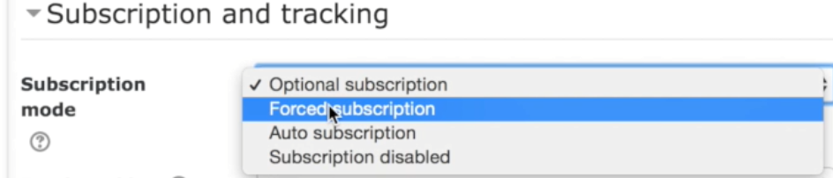
7. Read tracking- keep track of posts you have read.
8. Post threshold for blocking allows you to set parameters around how often a student posts.
9. Choose if you are going to grade and how.

